LAB221 Assignment | Type: | Short Assignment
 | Code: | J2.S.P0021
 | LOC: | 120
 | Slot(s): | 2

Title
Courses management
Background Context
In fact, we often work with list of objects like student, staff, customers,… rather than individual value.
Course management will guide you how to manage a list of objects, also how to work with many frames at a time.
Program Specifications
Create an application by using java swing, the interface of application look like below figure.
Function details:
- Display the main frame look like (1).
- When users select a function from frame do corresponding task in individual dialog.

Expectation of User interface:

CourseManagement.java

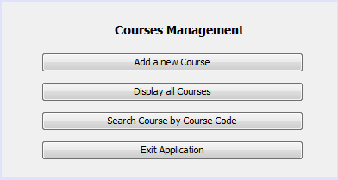 (1)

AddCourse.java
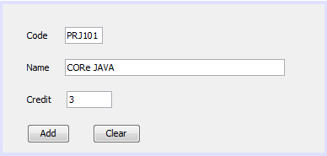

Requirements:
- Code, name and credit cannot be empty.
- Credit must be a positive number and less than or equals to 33.

SearchCourse.java
(Course name and credit are read only controls)

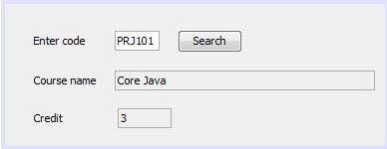

ListCourse.java
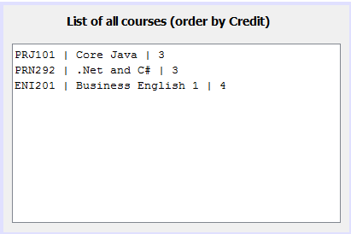

Guidelines

